Digital Electronic Assignment For F2 Grade

Assignment 1

- Convert the Decimal Number 250.5 to base 3, base 4, base 7 &amp; base 16.

convert 250.5 (base 10) into each requested base by separating:
- Integer part: 250
- Fractional part: 0.5

1. Base 3
Integer Part (250 → base 3)
Repeated division by 3:
Division | Quotient | Remainder
250 ÷ 3 | 83 | 1
83 ÷ 3 | 27 | 2
27 ÷ 3 | 9 | 0
9 ÷ 3 | 3 | 0
3 ÷ 3 | 1 | 0
1 ÷ 3 | 0 | 1
Read remainders bottom to top → 100021₃
Fractional Part (0.5 → base 3)
Multiply by 3 repeatedly:
- 0.5 × 3 = 1.5 → 1
- 0.5 × 3 = 1.5 → 1 (repeats forever)
So fractional part = 0.1111…₃ (recurring)
Answer (Base 3):
250.5₁₀ = 100021.1111…₃

2. Base 4
Integer Part (250 → base 4)
Division | Quotient | Remainder
250 ÷ 4 | 62 | 2
62 ÷ 4 | 15 | 2
15 ÷ 4 | 3 | 3
3 ÷ 4 | 0 | 3
Read bottom up → 3322₄
Fractional Part (0.5 → base 4)
- 0.5 × 4 = 2.0 → 2
Exact termination.
Answer (Base 4):
250.5₁₀ = 3322.2₄

3. Base 7
Integer Part (250 → base 7)
Division | Quotient | Remainder
250 ÷ 7 | 35 | 5
35 ÷ 7 | 5 | 0
5 ÷ 7 | 0 | 5
Read bottom up → 505₇
Fractional Part (0.5 → base 7)
- 0.5 × 7 = 3.5 → 3
- 0.5 × 7 = 3.5 → 3 (repeats)
Fraction = 0.3333…₇
Answer (Base 7):
250.5₁₀ = 505.3333…₇

4. Base 16 (Hexadecimal)
Integer Part (250 → base 16)
Division | Quotient | Remainder
250 ÷ 16 | 15 | 10
15 = F, 10 = A
Read bottom up → FA₁₆
Fractional Part (0.5 → base 16)
- 0.5 × 16 = 8.0 → 8
Answer (Base 16):
250.5₁₀ = FA.8₁₆

Final Results
Base | Result
Base 3 | 100021.1111…₃
Base 4 | 3322.2₄
Base 7 | 505.3333…₇
Base 16 | FA.8₁₆

- Represent the decimal number 8620 in BCD , Excess-3 , and Gray code

Digits: 8 6 2 0

1. BCD (8421 Code)
In BCD, each decimal digit is written in its 4-bit binary form.
Decimal Digit | BCD (8421)
8 | 1000
6 | 0110
2 | 0010
0 | 0000
BCD of 8620:
1000 0110 0010 0000

2. Excess-3 Code
Rule: Add 3 to each decimal digit, then convert to 4-bit binary.
Digit | +3 | Binary
8 | 11 | 1011
6 | 9 | 1001
2 | 5 | 0101
0 | 3 | 0011
Excess-3 of 8620:
1011 1001 0101 0011

3. Gray Code (4-bit Reflected Gray per digit)
Use the standard 4-bit Gray code table for digits 0–9.
Decimal Digit | Gray Code
8 | 1100
6 | 0101
2 | 0011
0 | 0000
Gray Code of 8620:
1100 0101 0011 0000

Final Answers
Code Type | Representation of 8620
BCD | 1000 0110 0010 0000
Excess-3 | 1011 1001 0101 0011
Gray | 1100 0101 0011 0000

- Find 1’s and 2’s complement of following binary nos.
Quick Reminder of the Method
1’s Complement
- Change all 0s to 1s and all 1s to 0s.
2’s Complement
- First find the 1’s complement
- Then add 1 to the result.

Example (just to show the process)
Suppose the binary number is 101100
1’s Complement:
101100 → 010011
2’s Complement:
010011 + 1 = 010100

- (1) (10001.101)2 (2) (101011.11101)2

(1) $\left(10001.101)_{2}\right.$
1’s Complement
Flip all bits (0 ↔ 1):
10001.101
↓
01110.010
1’s Complement = (01110.010)₂

2’s Complement
Add 1 to the 1’s complement:
01110.010
+ 00000.001
-----------
01110.011
2’s Complement = (01110.011)₂

(2) $\left(101011.11101)_{2}\right.$
1’s Complement
Flip all bits:
101011.11101
↓
010100.00010
1’s Complement = (010100.00010)₂

2’s Complement
Add 1 to the rightmost bit:
010100.00010
+ 000000.00001
--------------
010100.00011
2’s Complement = (010100.00011)₂

Final Answers
Binary Number | 1’s Complement | 2’s Complement
(10001.101)₂ | 01110.010₂ | 01110.011₂
(101011.11101)₂ | 010100.00010₂ | 010100.00011₂

- Find 9’s and 10’s complement of decimal nos.: 3405.65

- 9’s Complement → replace each digit d with 9 − d
- 10’s Complement → 9’s complement + 1 (add 1 to the least-significant digit)
The decimal point stays in the same position.

9’s Complement of 3405.65
Subtract each digit from 9:
Digit | 9 − Digit | Result
3 | 6 | 6
4 | 5 | 5
0 | 9 | 9
5 | 4 | 4
. | . | .
6 | 3 | 3
5 | 4 | 4
9’s Complement = 6594.34

10’s Complement of 3405.65
Step 1: Take 9’s complement → 6594.34
Step 2: Add 0.01 (since there are two decimal places)
6594.34
+ 0.01
---------
6594.35
10’s Complement = 6594.35

Final Answers
- 9’s Complement: 6594.34
- 10’s Complement: 6594.35

- Give full form for following abbreviations and explain: ASCII, EBCDIC
ASCII
Full Form: American Standard Code for Information Interchange
Explanation
ASCII is a character encoding standard used to represent text in computers and communication devices.
- It assigns numeric values to letters, digits, and symbols.
- Standard ASCII uses 7 bits → can represent 128 characters (0–127).
- Extended ASCII uses 8 bits → 256 characters.
Examples
- A → 65
- a → 97
- 0 → 48
- Space → 32
Key Points
- Developed in the 1960s in the USA.
- Very widely used in early computers and the internet.
- Simple and efficient for English text, but limited for other languages.

EBCDIC
Full Form: Extended Binary Coded Decimal Interchange Code
Explanation
EBCDIC is another character encoding system, mainly used by IBM mainframe computers.
- Uses 8 bits → can represent 256 characters.
- Different internal structure compared to ASCII.
- Not commonly used in modern personal computers.
Key Points
- Developed by IBM.
- Primarily used in banking systems, large enterprise servers, and legacy mainframes.
- Less universal than ASCII.

Main Differences
Feature | ASCII | EBCDIC
Full Form | American Standard Code for Information Interchange | Extended Binary Coded Decimal Interchange Code
Bits | 7 (standard) / 8 (extended) | 8
Characters | 128 / 256 | 256
Developed By | ANSI (USA) | IBM
Usage | PCs, internet, general computing | IBM mainframes, legacy systems
Popularity | Very high | Limited / specialized
In short:
ASCII became the global standard for text, while EBCDIC stayed mostly within IBM’s ecosystem.

Long Questions
- What is digital signal?
A signal is an electromagnetic or electrical current that carries data from one system or network to another. There are two main sorts of signals utilized in electronics: analog and digital signals.
What is Digital Signal?
Digital Signal: They represent information with a finite number of discrete values; they make use of something such as binary, namely the 0s and 1s, whereas analog signals change continuously. This characteristic leads to more preciseness in data encoding, increases immunity to noise and disturbances, and is suited to present applications such as telecommunications, computing, and multimedia. Digital signals ensure reliable transmission and processing of information by not allowing for more than possible values, thus guaranteeing greater accuracy and better dependability in communication systems.
- Variable electric current or voltage.
- Phase or polarization of an electromagnetic field.
- Acoustic pressure.
- The magnetization of a magnetic storage media.
- Digital signals are utilized in all digital electronics, including computing equipment and data transmission devices.
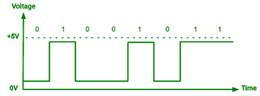Here, are essential characteristics of Digital signals as follows.
- Digital signal are discrete signals.
- This type of electronic l signals are often processed and transmitted better compared to analog signal.
- Digital signals are versatile, so it's widely used.
- The accuracy of the digital signal is best than that of the analog signal.
Advantages of Digital Signals
- Digital data can be easily compressed.
- Equipment that uses digital signals is more common and fewer expensive.
- These signals turn the moving instruments free from errors.
- You can edit the sound without altering the first copy.
- Digital signals can convey information with less noise, distortion, and interference.
- Digital signals can be reproduced easily in mass quantities at comparatively low costs.
- As the DSP operations are often altered that's why digital signal processing is more flexible.
- Digital signal processing is safer because digital information are often easily encrypted and compressed.
- Digital systems are more accurate, and therefore the probability of error occurrence are often reduced by employing error detection and correction codes.
- Digital signals are often easily stored on any magnetic media or optical media using semiconductor chips.
- Digital signals can be transmitted over long distances.
Disadvantage of Digital Signals
- Sampling may cause loss of information.
- A/D and D/A demands mixed-signal hardware.
- Processor speed is limited.
- Develop quantization and round-off errors.
- Systems and processing is more complex.
- A higher bandwidth is required for data communication in comparison to analog transmission of an equivalent information.
- Digital systems and processing are typically more complex.
Applications of Digital Signals
- Telecommunication: Telecommunication signals allow for data transmission to be supported with effective voice communication using VoIP over a long distance without loss. They are the heart of modern communication networks.
- Audio and Video Processing: Digital signals find application in audio compression, such as MP3, and video compression, for instance MPEG-4, whereby these enable the enhancement of qualities of media files while they reduce their size for streaming and storage.
- Control Systems: Digital signals drive automation in industrial processes and robotics, improving efficiency and precision in manufacturing and operational processes.
- Consumer Electronics: Digital signals are at the heart of image processing and audio playback in consumer electronics equipment, from cameras to smartphones.
- Data Storage: Digital signals allow storage on hard drives and SSDs very reliably. An appropriate digital output will make sure that the retrieved data is correct and preserved over time.

- What is a negative logic system?
In digital electronics, a logic or logic function is one that follows the rules that governs a logical statement. Logics are implemented by using switching networks, where a switching network is one that is designed by interconnecting a finite number of switches.
Example ? Let "?" is a logic function, then it may be expressed as,
x_{i} represents the inputs to the logic network or switching network, and y is the output of the network.
There is another term associated with the logic function that is the truth table. The truth table is used for testing the performance of the logic network. Another important point about logic systems is that they accept only two values namely 0 and 1. Here, 0 (binary zero) represents turn-off state of the circuit, while 1 (binary one) denotes the turn-on state of the logic circuit. Thus, in the truth table of a logic network, the entries are made using 0s and 1s.
The common examples of logic functions are OR, AND, NOT, NAND, NOR, XOR, XNOR, etc. Using these functions, we can implement more complex logic functions as well.
The logic in digital electronics are classified into two types ?
- Positive Logic
- Negative Logic
Now, let us discuss, the positive and negative logic in detail.
As discussed above, in digital systems, the variables associated with operations can have only two values, i.e. 0 and 1. Where, 0 and 1 represents the OFF (Logic LOW) and ON (Logic HIGH) state of the system respectively.
What is Positive Logic?
In digital electronic systems, if the high value of signal (voltage or current) is used to represent the logic 1 and the low value of signal (voltage or current) is used to represent the logic 0, then it is called a positive logic system.

The pulse waveform representation of a positive logic is shown in Figure-1. In the case of positive logic, the voltage at 0 volts level represents the logic 0 (Logic LOW), and the voltage at +VCC volts level represents the logic 1 (Logic HIGH).
In the generalized form, the positive logic is expressed as,
? Consider an NPN transistor. If the transistor is OFF, then its output will be at +VCC that represents the logic 1 (HIGH) state. On the other hand, if the transistor is ON, then its output will be 0 volts, and it represents the logic 0 (LOW) state.
What is Negative Logic?
In digital electronic systems, if the high value of signal (voltage or current) is used to represent the logic 0 and the low value of signal (voltage or current) is used to represent the logic 1, then it is called a negative logic system.

The pulse waveform representation of a negative logic is shown in Figure-2. In the case of negative logic, the voltage at -VCC volts level represents the logic 0 (Logic LOW), and the voltage at 0 volts level represents the logic 1 (Logic HIGH).
In the generalized form, the negative logic is expressed as,
? Consider a PNP transistor. If the transistor is OFF, then its output will be at -VCC volts that represents the logic 0 (LOW) state. On the other hand, if the transistor is ON, then its output will be 0 volts, and it represents the logic 1 (HIGH) state.

- What do you mean by positioned weighted system?
Positional number system is the type of number system in which the weight or value of the digit (or symbol) depends upon its position in the number. The positional number system is also known as weighted number system. This is because, in the positional number system, there is a weight associated with the position in the number.
Therefore, in the positional number system, each digit of the number is weighted according to its position of occurrence in the number. When we travel toward left along the number, the weights increase by a constant factor that is equivalent to the base of the number system. Also, in the positional number system, a radix point (.) is used to differentiate the positions corresponding to integral weights from the positions corresponding to the fractional weights.
Types of Positional Number Systems
There are four very popular positional number systems, which are:
- Decimal Number System
- Binary Number System
- Octal Number System
- Hexadecimal Number System
Let us discuss each of these number systems in detail.
Decimal Number System
The decimal number system is the most familiar number system for us. It is called decimal number system because its base or radix is ten (10). This means, it has 10 unique symbols, i.e. 0, 1, 2, 3, 4, 5, 6, 7, 8, and 9 to represent different numbers of the system. Also, there is no symbol for its base, i.e. for ten.
The decimal number system is a positional or weighted number system. Therefore, in this number system, the value of a symbol depends on its position (or location) with respect to the decimal point or radix point.
In the decimal number system, any number, whether it is an integer or fraction or mixed number, of any magnitude can be represented by using these ten symbols only. Each of these symbols is called a digit.
In a decimal number, the most left digit has the greatest positional weight out of all the digits present in the number, this is called the MSD (Most Significant Digit). On the other hand, the right most digit has the least positional weight out of all the digits present in the number, it is called LSD (Least Significant Digit).
In the decimal number system, the digits present on the left of the decimal point form the integral part of the decimal number, while the digits present on the right of the decimal point form the fractional part of the number. The digits in the integral part of the decimal number have weights that are positive powers of 10 (base), whereas, the digits in the fractional part of the decimal number have weights that are negative powers of 10.
A decimal number is generally expressed as,
binary number system is also a positional number system or a weighted number system. The base or radix of the binary number system is 2, which means it has two unique symbols, i.e. 0 and 1 to represent numbers. Similar to decimal number system, the base of the binary number system itself cannot be a symbol.
In the binary number system, each digit is called a bit (binary digit). Thus, a binary number is nothing but a string of binary 0s and 1s. There is a binary point (radix point) that separates the integral and fractional parts of the binary number. Each binary digit or bit in a binary number carries a weight according to its position with respect to the binary point.
In the case of binary number system, the weight of each position is expressed in terms of power of 2, i.e. , where n = ?, -3, -2, -1, 0, 1, 2, 3,?. The positive power of 2 represents the weight of a bit on the left side of the binary point, while the negative power of 2 represents the weight of a bit on the right side of the binary point.
A binary number with bits in its integral part and -m bits in its fractional part is expressed as,
is again a type of positional number system. That means, the value of a digit in an octal number depends upon its position in the number. The base or radix of the octal number system is 8, thus, the octal number system has eight unique symbols, i.e. 0, 1, 2, 3, 4, 5, 6, and 7. The octal number system was widely used in early minicomputers.
The generalized form of an octal number having "n+1" digits in its integral part and "-m" digits in its fraction part is,
hexadecimal number system is also a type of positional or weighted number system. The base or radix of the hexadecimal number system is 16, which means there are sixteen independent symbols present in this system. These symbols are 0, 1, 2, 3, 4, 5, 6, 7, 8, 9, A, B, C, D, E, and F. All the numbers in hexadecimal number system can be expressed using these symbols

Assignment 2
  - Subtract : 1011-101,10110-1011,1100.10-111.01
1. Binary Subtraction

(a) ${1011}_{2}-{101}_{2}$
Convert to decimal for quick check:
1011₂ = 11₁₀, 101₂ = 5₁₀ → 11 − 5 = 6
Binary subtraction:
1011
- 0101
------
0110
Answer: 110₂

(b) ${10110}_{2}-{1011}_{2}$
10110₂ = 22₁₀
1011₂ = 11₁₀ → 22 − 11 = 11
10110
-01011
------
01011
Answer: 1011₂

(c) ${1100.10}_{2}-{111.01}_{2}$
Convert to decimal to verify:
1100.10₂ = 12.5₁₀
111.01₂ = 7.25₁₀ → 12.5 − 7.25 = 5.25
Binary subtraction:
1100.10
-0111.01
--------
0101.01
Answer: 101.01₂

  - Divide : 1010 by 11, 11110 by 101 ,11011 by 10.1

2. Binary Division

(a) ${1010}_{2}÷{11}_{2}$
1010₂ = 10₁₀
11₂ = 3₁₀ → 10 ÷ 3 = 3 remainder 1
Binary result:
- Quotient = 11₂
- Remainder = 1₂

(b) ${11110}_{2}÷{101}_{2}$
11110₂ = 30₁₀
101₂ = 5₁₀ → 30 ÷ 5 = 6
Binary:
- Quotient = 110₂
- Remainder = 0

(c) ${11011}_{2}÷{10.1}_{2}$
Convert to decimal:
11011₂ = 27₁₀
10.1₂ = 2.5₁₀ → 27 ÷ 2.5 = 10.8₁₀
10.8₁₀ in binary = 1010.1100…₂ (recurring)
Answer: ≈ 1010.11₂ (approx.)

  - What is the principle of Duality Theorem?
- The Duality Theorem states that every Boolean algebraic expression remains valid if the operators and identity elements are swapped (AND ↔ OR, 0 ↔ 1).
- If an expression F is valid, then its dual F^{D} is also valid, where F^{D} is obtained by replacing all + with . , . with +, 0 with 1, and 1 with 0.

    - Explain briefly: standard SOP and POS forms.
- SOP vs POS
Characterization | SOP | POS
Definition | SOP is sum of the minterms. | POS is the product of maxterms.
Stands for | SOP stands for Sum of Product. | POS stands for Product of Sum.
Representation | It represents minterms. | It represents maxterms.
Logic | It works on active high logic. | It works on active low logic.
Denotation | It is denoted by Σ. | It is denoted by П.
Output | The output of SOP is 1. | The output of POS is 0.

5. Demonstrate by means of truth tables the validity of the following Theorems of
Boolean algebra (1) De Morgan’s theorems for three variables

De Morgan's Law in Set Theory
De Morgan's law in set theory defines the relationship between the union, intersection, and complements of the sets, and is given for both the complement of the union and the intersection of two sets. In set theory, there are two De Morgan's Laws that are:
- First De Morgan's Law
- Second De Morgan's Law
Let's understand these laws in detail as below:
First De Morgan's Law
First De Morgan's law states that "The complement of the union of two sets is equal to the intersection of the complements of each set."
Let A and B be two sets, then mathematically First De Morgan's Law is given as:
(A ∪ B)' = A' ∩ B'
Where
- U represents the Union operation between sets,
- ∩ represents the intersection operation between sets, and
- ' represents complement operation on a set.
It is also called De Morgan's Law of Union.
Detail the Proof of De Morgan's Law
Step | Explanation
Step 1: State the Law | De Morgan's Law includes two parts: ¬(A ∪ B) = ¬A ∩ ¬B and ¬(A ∩ B) = ¬A ∪ ¬B.
Step 2: Choose an Element | Let's prove ¬(A ∪ B) = ¬A ∩ ¬B. Assume an element x that is not in A ∪ B.
Step 3: Understand the Assumption | If x is not in A ∪ B, then x is neither in A nor in B.
Step 4: Apply the Definition | By the definition of complement, if x is not in A and not in B, then x is in ¬A and in ¬B.
Step 5: Conclude the Proof | Since x is in both ¬A and ¬B, x is in ¬A ∩ ¬B. Thus, we've shown ¬(A ∪ B) = ¬A ∩ ¬B.
Proof Using Algebra of Sets
We need to prove, (A ∪ B)' = A' ∩ B'
Let X = (A ∪ B)' and Y = A' ∩ B'
Let p be any element of X, then p ∈ X ⇒ p ∈ (A ∪ B)'
⇒ p ∉ (A ∪ B)
⇒ p ∉ A or p ∉ B
⇒ p ∈ A' and p ∈ B'
⇒ p ∈ A' ∩ B'
⇒ p ∈ Y
∴ X ⊂ Y . . . (i)
Again, let q be any element of Y, then q ∈ Y ⇒ q ∈ A' ∩ B'
⇒ q ∈ A' and q ∈ B'
⇒ q ∉ A and q ∉ B
⇒ q ∉ (A ∪ B)
⇒ q ∈ (A ∪ B)'
⇒ q ∈ X
∴ Y ⊂ X . . . (ii)
From (i) and (ii) X = Y
(A ∪ B)' = A' ∩ B'
Also Read - Proof of De-Morgan’s laws in boolean algebra
Proof Using a Venn Diagram
Venn Diagram for (A ∪ B)'
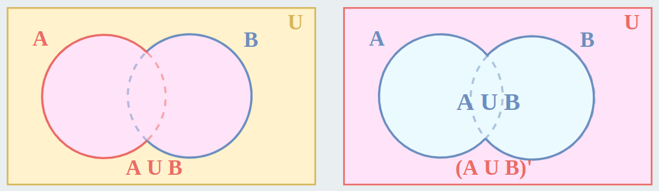
Venn Diagram for A' ∩ B'
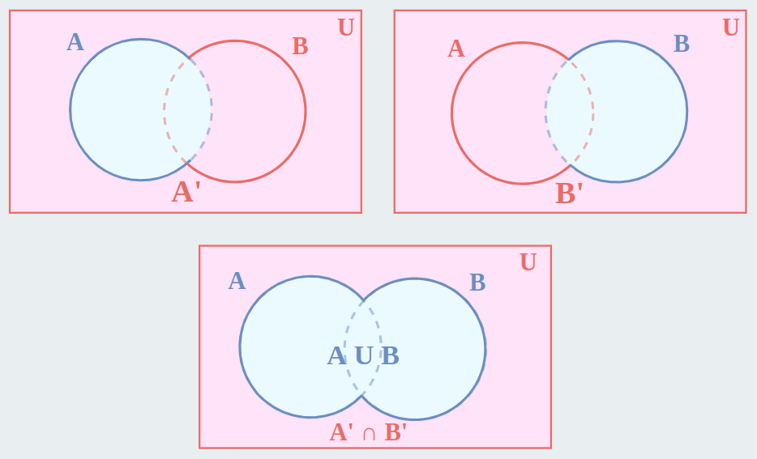
From both Diagrams, we can clearly say,
(A ∪ B)' = A' ∩ B'
That is the First De Morgan's Law.
Second De Morgan's Law
Second, De Morgan's law states that "The complement of intersection of two sets is equal to the union of the complements of each set."
Let A and B be two sets, then mathematically First De Morgan's Law is given as:
(A ∩ B)' = A' ∪ B'
Where
- U represents the Union operation between sets,
- ∩ represents the intersection operation between sets, and
- ' represents complement operation on a set.
It is also called De Morgan's Law of Intersection.
Proof Using Algebra of Sets
Second De Morgan's law: (A ∩ B)' = A' ∪ B'
Let X = (A ∩ B)' and Y = A' ∪ B'
Let p be any element of X, then p ∈ X ⇒ p ∈ (A ∩ B)'
⇒ p ∉ (A ∩ B)
⇒ p ∉ A or p ∉ B
⇒ p ∈ A' or p ∈ B'
⇒ p ∈ A' ∪ B'
⇒ p ∈ Y
∴ X ⊂ Y --------------(i)
Again, let q be any element of Y, then q ∈ Y ⇒ q ∈ A' ∪ B'
⇒ q ∈ A' or q ∈ B'
⇒ q ∉ A and q ∉ B
⇒ q ∉ (A ∩ B)
⇒ q ∈ (A ∩ B)'
⇒ q ∈ X
∴ Y ⊂ X --------------(ii)
From (i) and (ii) X = Y
(A ∩ B)' = A' ∪ B'
Proof Using Venn Diagram
Venn Diagram for (A ∩ B)'
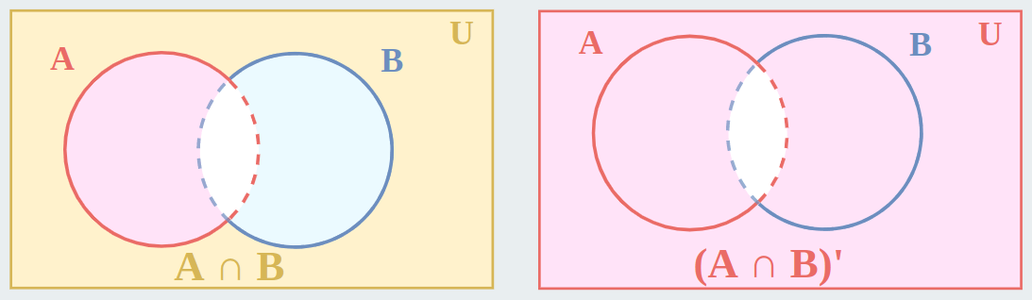
Venn diagram for A' ∪ B'
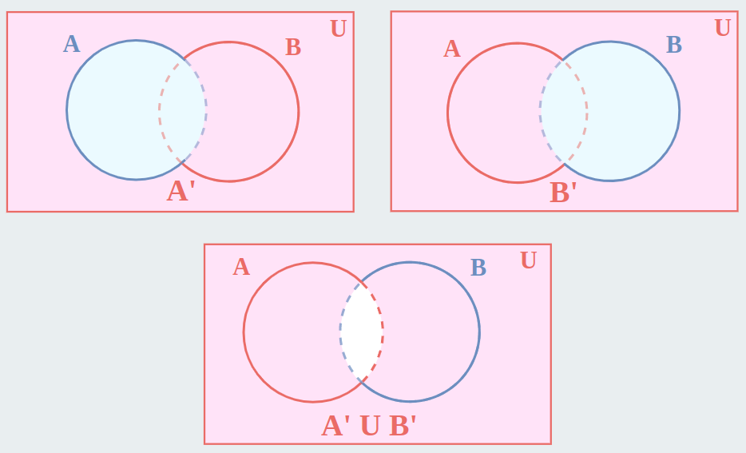
From both diagrams, we can clearly say
(A ∩ B)' = A' ∪ B'
That is the Second De Morgan's Law.
De Morgan's Law in Boolean Algebra
De Morgan's Law Boolean Algebra defines the relation between the OR, AND, and the complements of variables, and is given for both the complement of AND and OR of two values. In Boolean Algebra there are two De Morgan's Laws that are:
- First De Morgan's Law
- Second De Morgan's Law
Let's understand these laws in detail as below:
First De Morgan's Law in Boolean Algebra
First De Morgan's law states that "The complement of OR of two or more variables is equal to the AND of the complement of each variable."
Let A and B be two variables, then mathematically First De Morgan's Law is given as:
(A + B)' = A' . B'
Where
- + represents the OR operator between variables,
- . represents AND operator between variables, and
- ' represents complement operation on the variable.
First De Morgan's Law Logic Gates
In context to logic gates and Boolean Algebra, De Morgan's Law states that "Both the logic gate circuits i.e., NOT gate is added to the output of OR gate, and NOT gate is added to the input of AND gate, are equivalent. These two logic gate circuits are given as follows:
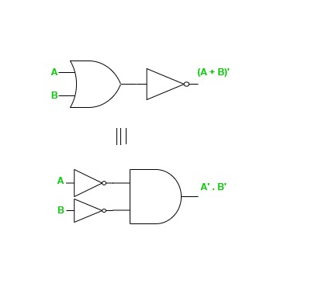
First De Morgan's Law Truth Table
The truth table for first De Morgan's Law is given as follows:
A | B | A + B | (A + B)' | A' | B' | A'. B'
0 | 0 | 0 | 1 | 1 | 1 | 1
0 | 1 | 1 | 0 | 1 | 0 | 0
1 | 0 | 1 | 0 | 0 | 1 | 0
1 | 1 | 1 | 0 | 0 | 0 | 0
Second De Morgan's Law in Boolean Algebra
Second De Morgan's law states that "The complement of AND of two or more variables is equal to the OR of the complement of each variable."
Let A and B be two variables, then mathematically Second De Morgan's Law is given as:
(A . B)' = A' + B'
Where
- + represents the OR operator between variables,
- . represents AND operator between variables, and
- ' represents complement operation on variable.
Second De Morgan's Law Logic Gates
In context to logic gates and Boolean Algebra, De Morgan's Law states that "Both the logic gate circuits i.e., NOT gate is added to the output of AND gate, and NOT gate is added to the input of OR gate, are equivalent. These two logic gate circuits are given as follows:
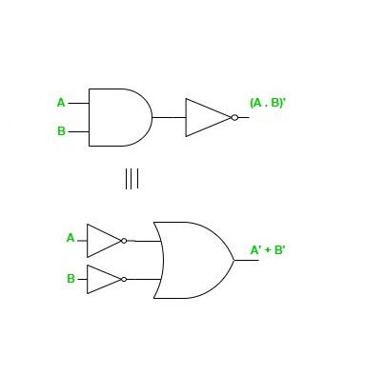
Second De Morgan's Law Truth Table
The truth table for the second De Morgan's Law is given as follows:
A | B | A . B | (A. B)' | A' | B' | A' + B'
0 | 0 | 0 | 1 | 1 | 1 | 1
0 | 1 | 0 | 1 | 1 | 0 | 1
1 | 0 | 0 | 1 | 0 | 1 | 1
1 | 1 | 1 | 0 | 0 | 0 | 0
De Morgan's Law of Logic
In De Morgan's law for logic the below propositions are tautology:
∼ (a ∧ b) ≡ ∼ a ∨ ∼ b
∼ (a ∨ b) ≡ ∼ a ∧ ∼ b
Where,
- ∧ represents the conjunction of statements,
- ∨ represents the disjunction of statements,
- ~ represents the negation of a statement, and
- ≡ represents the equivalence of statements.
De Morgan's Law Formula
Let's compile all the formulas for De Morgan's Law in the following list.
For set theory:
- (A ∪ B)' = A' ∩ B'
- (A ∩ B)' = A' ∪ B'
For Boolean Algebra:
- (A + B)' = A' . B'
- (A . B)' = A' + B'
For Logic:
- ∼ (a ∧ b) ≡ ∼ a ∨ ∼ b
- ∼ (a ∨ b) ≡ ∼ a ∧ ∼ b
De Morgan's Law Practical Examples
Example 1: Pizza Toppings
Imagine you're at a pizza party, and you're told you can choose any toppings except for both mushrooms and olives together.
- Using De Morgan's Law: This means if you don't want both mushrooms and olives (Not (Mushrooms and Olives)), you can either not have mushrooms (Not Mushrooms) or not have olives (Not Olives) on your pizza. So, you could have a pizza with just mushrooms, just olives, or neither!
Example 2: Library Books
Your teacher says you cannot bring books about wizards or dragons into the classroom.
- Using De Morgan's Law: This means if you're not allowed books about wizards or dragons (Not (Wizards or Dragons)), you can't bring books about wizards (Not Wizards) and you can't bring books about dragons (Not Dragons). So, books about space or animals are still okay!
Example 3: Playing Outside
Your mom says you can't play outside if it's raining and cold at the same time.
- Using De Morgan's Law: This means if you're not going out because it's raining and cold (Not (Raining and Cold)), you wouldn't go out if it's just raining (Not Raining) or just cold (Not Cold). But if it's sunny and warm, you're good to go!
Example 4: Choosing a Movie
Your friend says they don't want to watch a movie that is scary or boring.
- Using De Morgan's Law: This means if your friend doesn't want a movie that's scary or boring (Not (Scary or Boring)), they don't want a scary movie (Not Scary) and they don't want a boring movie (Not Boring). So, a funny or exciting movie would be perfect!

6. Express the following functions in sum of min terms and product of max
terms: F(A,B,C,D) = D(A’+B) + B’D

Step 1 – Simplify the Function
$$F=D(A^{'}+B)+B^{'}D$$
Factor D:
$$F=D[(A^{'}+B)+B^{'}] \\ =D(A^{'}+B+B^{'})$$
Since $B+B^{'}=1$:
$$F=D(A^{'}+1)=D⋅1=D$$
So the function simplifies to:
$$F=D$$

Step 2 – Sum of Minterms (Canonical SOP)
For 4 variables $A,B,C,D$, minterms range from 0 to 15.
Since $F=D$, the output is 1 whenever $D=1$.
That means all minterms where the last bit is 1.
These are:
$$m(1,3,5,7,9,11,13,15)$$
Sum of Minterms form:
$$F(A,B,C,D)=Σm(1,3,5,7,9,11,13,15)$$

Step 3 – Product of Maxterms (Canonical POS)
Maxterms occur where $F=0$.
Since $F=D$, output is 0 whenever D = 0.
These indices are:
$$M(0,2,4,6,8,10,12,14)$$
Product of Maxterms form:
$$F(A,B,C,D)=ΠM(0,2,4,6,8,10,12,14)$$

Final Answer
- Simplified Function: $F=D$
- Sum of Minterms: $Σm(1,3,5,7,9,11,13,15)$
- Product of Maxterms: $ΠM(0,2,4,6,8,10,12,14)$

  - Reduce the expression: A+B(AC+(B+C’)D)

Step-by-Step Reduction
1. Expand inside the bracket
$$=A+B⋅AC+B(B+C^{'})D$$

2. Simplify terms
Term 1:
$$B⋅AC=ABC$$
Term 2:
$$B(B+C^{'})D$$
Use identity $X(X+Y)=X$:
$$B(B+C^{'})=B$$
So,
$$B(B+C^{'})D=BD$$
Now expression becomes:
$$A+ABC+BD$$

3. Apply Absorption Law
$$A+ABC=A$$
So final expression:
$$A+BD$$

Final Reduced Form
$$\boxed{A+BD}$$

8. Simplify the following Boolean expression using k-map and verify it using the
Quine Mc Cluskey method (Tabular Method) F(A,B,C,D)=Σ
m(0,1,3,7,8,9,11,15)

1. K–Map Simplification
Minterms
$$0,1,3,7,8,9,11,15$$
Binary (A B C D):
m | A B C D
0 | 0000
1 | 0001
3 | 0011
7 | 0111
8 | 1000
9 | 1001
11 | 1011
15 | 1111

4-Variable K-Map Grouping (Logic Result)
Observations from grouping:
- All minterms with C=1 and D=1 → $CD$
(3,7,11,15)
- All minterms with B=0 and C=0 → $B^{'}C^{'}$
(0,1,8,9)

K-Map Simplified Expression
$$\boxed{F=B^{'}C^{'}+CD}$$

2. Quine–McCluskey (Tabular Method) Verification

Step 1 – Group by Number of 1s
Group | Minterms | Binary
0 ones | 0 | 0000
1 one | 1,8 | 0001, 1000
2 ones | 3,9 | 0011, 1001
3 ones | 7,11 | 0111, 1011
4 ones | 15 | 1111

Step 2 – First Combining
Examples of valid combinations:
- 0000 & 0001 → 000–
- 0000 & 1000 → –000
- 0001 & 0011 → 00–1
- 0001 & 1001 → –001
- 0011 & 0111 → 0–11
- 0011 & 1011 → –011
- 0111 & 1111 → –111
- 1011 & 1111 → 1–11

Step 3 – Second Combining
Further merging gives prime implicants:
- –0 0 – → $B^{'}C^{'}$
- – – 1 1 → $CD$
(No more reduction possible.)

Step 4 – Prime Implicant Chart
Minterm | B'C' | CD
0 | ✔
1 | ✔
3 |  | ✔
7 |  | ✔
8 | ✔
9 | ✔
11 |  | ✔
15 |  | ✔
Both implicants are essential.

Final Simplified Function
$$\boxed{F(A,B,C,D)=B^{'}C^{'}+CD}$$
9. Reduce the following expressions using a three variable map.
a. F=AB′C+A′BCD′+ABC′D+ABC
First notice the variables involved are A, B, C, D → this is actually a 4-variable function (not 3).
So we reduce it logically (equivalent to a 4-variable K-map result).

Step 1 – Write terms clearly
$$F=AB^{'}C+A^{'}BCD^{'}+ABC^{'}D+ABC$$
Group similar terms.

Step 2 – Combine obvious terms
Combine $AB^{'}C$and $ABC$
$$AB^{'}C+ABC=AC(B^{'}+B)=AC$$
So now:
$$F=AC+A^{'}BCD^{'}+ABC^{'}D$$

Step 3 – Factor remaining two terms
$$A^{'}BCD^{'}+ABC^{'}D$$
Take out B:
$$=B(A^{'}CD^{'}+AC^{'}D)$$
Inside bracket is XOR form:
$$A^{'}CD^{'}+AC^{'}D=A⊕C\text{ (with D involved)}$$
But we keep SOP form for Boolean reduction.

Step 4 – Try absorption with $AC$
Check if $AC$absorbs anything:
- $ABC^{'}D$is not absorbed by $AC$because of $C^{'}$
- $A^{'}BCD^{'}$also not absorbed
So minimal SOP becomes:
$$F=AC+A^{'}BCD^{'}+ABC^{'}D$$

Final Reduced Expression
$$\boxed{F=AC+A^{'}BCD^{'}+ABC^{'}D}$$
This is the minimized Sum-of-Products form.

10. Prove that: AB′C+B+BD′+ABD′+A′C=B+C

Step–by–Step Proof
Start with
$$F=AB^{'}C+B+BD^{'}+ABD^{'}+A^{'}C$$

1. Use Absorption with B
$$B+BD^{'}=B \\ B+ABD^{'}=B$$
So the expression reduces to:
$$F=AB^{'}C+B+A^{'}C$$

2. Rearrange
$$F=B+AB^{'}C+A^{'}C$$
Factor C from the last two terms:
$$=B+C(AB^{'}+A^{'})$$

3. Simplify inside bracket
Use identity:
$$AB^{'}+A^{'}=(A^{'}+B^{'})$$
So,
$$F=B+C(A^{'}+B^{'})$$

4. Distribute $C$
$$F=B+A^{'}C+B^{'}C$$

5. Combine $B+B^{'}C$
Use identity:
$$X+X^{'}Y=X+Y \\ B+B^{'}C=B+C$$
So,
$$F=(B+C)+A^{'}C$$

6. Absorption Again
$$C+A^{'}C=C$$
Therefore,
$$F=B+C$$

Final Result
$$\boxed{AB^{'}C+B+BD^{'}+ABD^{'}+A^{'}C=B+C}$$

Assignment 3
  - Express Function in sum of Minterms (SOP)
In the sum of the product form of representation, The product num is logical and operation of the different input variables where the variables could be in the true form or in the complemented form.
The Sum of Product (SOP) form refers to a Boolean expression where several product terms (involving AND operations) are added up. This is perhaps the most popular form used in the design and optimization of digital systems. In SOP format, each of those elements is a combination (ANDing) of some variables (or their negations); all of them are combined by means of disjunction (ORing). This is very helpful in, for instance, the creation of logic circuits from truth tables or achieving algorithmic simplifications of logic functions.
Example:
A.B, A.B̅.C (example of product term)
In SOP sum refers to logical OR Operation. Therefore, in this sum of product form of expression, we perform logical or operations on different product terms. Therefore it is known as the Sum of Product form.
Example:
A+ B̅.C + A.C
as we can see in above example the product terms(A , B̅.C , A.C) which are created by multiplying input variables are are summed with each other .
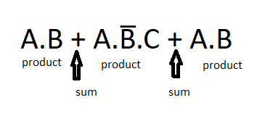SOP Form
The SOP form can be in either canonical form or non-canonical form.
1. Non-Canonical SOP Form
In this form each product term between may or may not contain all the variables of the function.
Example:
F(A,B,C) = A+ B̅.C + A.C
as we can see in above example the function have variables A, B, C but we are not including each variable in each product term. in first product term (A) we have not included B & C. In second product term we (B̅.C) have not included A. While in last product term we have not included B.
2. Canonical SOP Form
In canonical SOP form each product term contains all the variables of the function, where variables in each product term can be in true form or complemented form.
Example :
F(A,B) = Ā.B + A.B̅
As we can see in above example each product term contain all the variables which are present in function. In first one(Ā.B) A is present in complementary form while B is in true form. In second one A is present in true form while B is in complementary form.
Writing Boolean Expression for Given Truth Table in SOP Form
Suppose following is the truth table for an electronic circuit:
A | B | C | F
0 | 0 | 0 | 0
0 | 0 | 1 | 0
0 | 1 | 0 | 1
0 | 1 | 1 | 0
1 | 0 | 0 | 1
1 | 0 | 1 | 1
1 | 1 | 0 | 1
1 | 1 | 1 | 1
The SOP form is written when the function if high. i.e we will take conditions only in which the output is one. In given truth table the columns with F = 1 are the rows with high output. Now we will write function in the form of given variables which are A, B and C. If we have 1 in the cell of given variable we will write it as it is , and if we have 0 in the given cell then we will write it's complement.
F = Ā.B.C̅ + A.B̅.C̅ + A.B̅.C + A.B.C
This is the POS in canonical form for the given truth table. Each expressions which lies in between the + are known as Minterms.
Example :
A.B.C, A.B̅.C
Therefore we can also write it as
F(A, B, C) = M2 + M4 + M5 + M6 + M7
F(A,B,C) = ∑m(2, 4, 5, 6, 7)
we can further reduce it to non-canonical SOP form by using boolean algebra.
F = Ā.B.C̅ + A.B̅.C̅ + A.B̅.C + A.B.C
F = Ā.B.C̅ + A.B̅.[C̅ + C] + A.B.[C̅ + C]
F = Ā.B.C̅ + A.B̅ + A.B
F = Ā.B.C̅ + A.[B̅ + B]
F = A + B.C̅
This is how we can get non-canonical SOP form of Boolean expression.
Creating a Truth Table with SOP Boolean Expressions
Suppose following is the SOP expression for which we will make truth table now
F(A, B, C) = A'B' + AB + AC
1. As we have three input values (A, B, C) we will create 2^3 = 8 rows in truth table to include all input combinations.
A | B | C
0 | 0 | 0
0 | 0 | 1
0 | 1 | 0
0 | 1 | 1
1 | 0 | 0
1 | 0 | 1
1 | 1 | 0
1 | 1 | 1
2. for each input combination we will put values of input in expression and calculate the output:
F(A, B, C) = A'B' + AB + AC
F(0, 0, 0) = 0'0' + 00 + 00 = 0 + 0 + 0 = 0
F(0, 0, 1) = 0'0' + 00 + 01 = 0 + 0 + 0 = 0
F(0, 1, 0) = 0'1' + 01 + 00 = 0 + 0 + 0 = 0
F(0, 1, 1) = 0'1' + 01 + 01 = 0 + 0 + 0 = 0
F(1, 0, 0) = 1'0' + 10 + 10 = 0 + 0 + 0 = 0
F(1, 0, 1) = 1'0' + 10 + 11 = 0 + 0 + 1 = 1
F(1, 1, 0) = 1'1' + 11 + 10 = 0 + 1 + 0 = 1
F(1, 1, 1) = 1'1' + 11 + 11 = 0 + 1 + 1 = 1
3. Create truth table form given input combinations and calculated output.
A | B | C | F
0 | 0 | 0 | 0
0 | 0 | 1 | 0
0 | 1 | 0 | 0
0 | 1 | 1 | 0
1 | 0 | 0 | 0
1 | 0 | 1 | 1
1 | 1 | 0 | 1
1 | 1 | 1 | 1
Advantages of SOP
- Simple to derive: Since truth tables are often used for generating Sankey diagrams, the implementation is straightforward using basic logic gates including AND and OR.
- In case of Complexity: There may be cases where the simpler formulation of a certain equation in a digital system design is not possible since a simpler version is required but a Boolean equivalent transformation does exist.
- Uniformity in Presentation: SOP offers a way to encode Boolean functions in a consistent manner. This is helpful when creating devices that utilize combinational logic.
- Easy Implementation: The design of the SOP can be easily constructed in a digital circuit by the use of AND-OR gates, which is advantageous in the design of hardware.
Disadvantages of SOP
- Can lead to complex circuits: In scenarios where minimization is not employed, the SOP representation can lead to expansive and complex circuits, leading to increased hardware expenditure as well as power usage.
- Not Suitable for Large Functions: As the number of variables in the function increases, the number of product terms also increases; therefore the expression as well as the corresponding circuit becomes bigger.
- Not Always the Simplest Version Possible: Of some functions, for instance, SOP optimized to the minimizing level is usually an ineffective option in representing a particular function than other options like the POS.
Applications of SOP
- Digital Circuit Design: The SOP form is utilized very often in the implementation of combinational circuits like multiplexers, encoders and decoders among others.
- Logic Minimization: Most of the logic minimization approaches ranging from Karnaugh mapping to Quine-McCluskey uses the standard sum of product for better construction of digital circuits.
- Programmable Logic Arrays (PLAs): In PLAs, which is a configurable device, the logic is defined with the help of SOP expressions.
- Design Finite State Machine: When designing finite state machine, the transition logic between the different states is expressed in the form of SOP.

  - Explain briefly : Minterm &amp; Maxterm and canonical form
Minterms and Maxterms are important parts of Boolean algebra. Minterm is the product of N distinct literals where each literal occurs exactly once. The output of the minterm functions is 1. Minterm is represented by m. Maxterm is the sum of N distinct literals where each literals occurs exactly once. The output of the maxterm functions is 0. Maxterm is represented by M. In this article we will learn about minterms and maxterms, their difference, why we use minterms and maxterms along with the solved examples.
What is Minterm?
Minterm is the product of various different literals in which each literal occurs exactly once. The output result of the minterm functions is 1. It is represented by m. To represent a function, we perform a sum of minterms also called the Sum Of Products (SOP).
Example of SOP:
A'B + AC + BC
Table for Two-Variable Minterm
Variable |  | Minterm
A | B | Term | Repres entation
0 | 0 | A'B' | m₀
0 | 1 | A'B | m₁
1 | 0 | AB' | m₂
1 | 1 | AB | m₃
Minterms for Values
Minterms for values is the minterms obtained by the values of the Boolean variable.
Steps for Obtaining Minterms from Values
1. If the value of the Boolean variable is 1 then we will take the variable without complementing it.
2. If the value of the Boolean variable is 0 then we will take the variable by complementing it.
Minterm Example:
If there are four Boolean variables A, B, C, D with the values A = 1, B = 0, C = 0 and D = 1. Find the minterms for values given.
Solution:
Given the values of the Boolean variables:
A = 1, B = 0, C = 0 and D = 1
The required minterm is given by = AB'C'D
We complemented B and C as its value is 0.
What is Maxterm?
Maxterm is the sum of various different literals in which each literal occurs exactly once. The output result of the maxterm functions is 0. It is represented by M. To represent a function, we perform product of maxterms also called Product of Sum (POS).
Example of POS:
(A+B). (C+D)
Table for Two Variable Maxterm
Variable |  | Maxterm
A | B | Term | Representation
0 | 0 | A+B | M0
0 | 1 | A+B' | M1
1 | 0 | A'+B | M2
1 | 1 | A'+B' | M3
Maxterms for Values
Maxterms for values is the maxterms obtained by the values of the Boolean variable.

  - What do you mean by code converter?
- Code Converters are the digital circuits or algorithms that are designed to translate data representation from one format to the other format. In this article, we will go through binary to gray code converters. The binary-to-Gray code converter takes binary input and translates it to its corresponding gray code representation.
- For more about conversions please go through Number System and base conversions.

4. Design code converter to convert BCD to excess-3.
1. BCD (8421) Code
BCD (Binary Coded Decimal) is a way to represent each decimal digit individually using binary numbers. The most common form, called the 8421 code, assigns a unique 4-bit binary number to each decimal digit from 0 to 9.
0 is represented as 0000
1 is represented as 0001
2 is represented as 0010
3 is represented as 0011
4 is represented as 0100
5 is represented as 0101
6 is represented as 0110
7 is represented as 0111
8 is represented as 1000
9 is represented as 1001
For example,
Let's take the decimal number 59.
- The digit 5 in BCD (8421) is 0101
- The digit 9 in BCD (8421) is 1001
So, the decimal number 59 is represented in BCD as 0101 1001.
The 8421 code is widely used in applications that require precise decimal calculations, such as digital clocks, calculators, and financial systems. By encoding each digit separately, BCD simplifies arithmetic operations and makes converting between decimal and binary straightforward, ensuring fast and reliable digital processing.
2. Excess-3 Code
Excess-3 code is a BCD code where each decimal digit is represented by its 4-bit binary value plus 3. For example, decimal 0 is 0011 in Excess-3 (0 + 3 = 3 in binary). This code is self-complementary, meaning the 1's complement of an Excess-3 number equals the Excess-3 code of the 9's complement of the decimal digit.
For example,
Decimal 3 in BCD is 0011; in Excess-3, it is 0110 (3 + 3).
The 1's complement of 0110 is 1001, which is the Excess-3 code for 6 (9 - 3), showing the self-complementary property.
Excess-3 simplifies subtraction and complements in digital systems by allowing bit inversion to find 9's complements.
Converting BCD(8421) to Excess-3
As is clear by the name, a BCD digit can be converted to its corresponding Excess-3 code by simply adding 3 to it. Since we have only 10 digits(0 to 9) in decimal, we don't care about the rest and marked them with a cross(X).
Let A, B, C and D be the bits representing the binary numbers, where D is the LSB and A is the MSB, and let w, x, y and z be the bits representing the gray code of the binary numbers, where z is the LSB and w is the MSB.
The truth table for the conversion is given below. The X's mark is don't care condition.
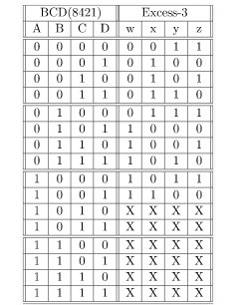
To find the corresponding digital circuit, we will use the K-Map technique for each of the Excess-3 code bits as output with all of the bits of the BCD number as input.

5. Design Full adder using two half adder.
What is Half Adder?
Half adder is a combinational circuit that is used to add two 1-bit inputs to generate two outputs sum and carry. The sum in half adder is given by XORing both the inputs. The carry in the half adder is given by the product of both inputs. Half Adders are used in the Various Digital Systems Where Addition of Binary Numbers is Required Such as Arithmetic Circuits, Digital Calculators, Microcontrollers and Processors, Communication systems and Control Systems.
Expression for Sum in Half Adder
From the above truth table, the expression for sum S in half adder is:
S = A ⊕ B
where,
A and B are inputs and ⊕ represents XOR operation
Expression for Carry in Half Adder
From the above truth table, the expression for carry C in half adder is:
C = AB
Logic Diagram for Half Adder
To implement half adder, we require one XOR gate and one AND gate. Below is the logic diagram for half adder.

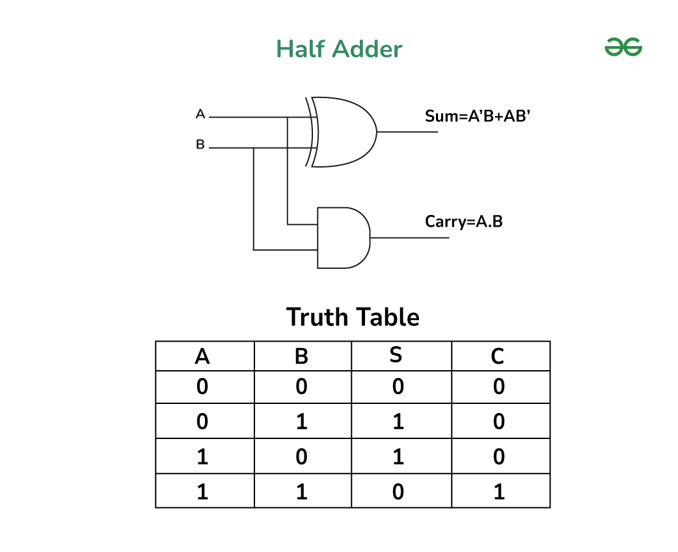Half Adder

Block Diagram for Half Adder
Below is the block diagram for half adder.
Block Diagram of half Adder

What is Full Adder?
Full adder is a combinational circuit that is used to add three 1-bit inputs to generate two outputs sum and carry. The sum in full adder is given by XORing all the inputs. The carry in the full adder is given by sum of product of two inputs. Full Adders are important component in digital Circuit and are used in the ALUs (Arithmetic Logic Units),Binary Additions, Address decoding, Counters and Registers, Data Encryption and Decryption and Digital Signal Processing.
Expression for Sum in Full Adder
From the above truth table, the expression for sum S in half adder is:
S = A ⊕ B ⊕ C
where,
A, B and C are inputs and ⊕ represents XOR operation.
Expression for Carry in Full Adder
From the above truth table, the expression for carry in half adder is:
Carry = AB + BC + AC
Logic Diagram for Full Adder
To implement full adder, we require 2 XOR gate, 2 AND gate and 1 OR gate. Below is the logic diagram for full adder.
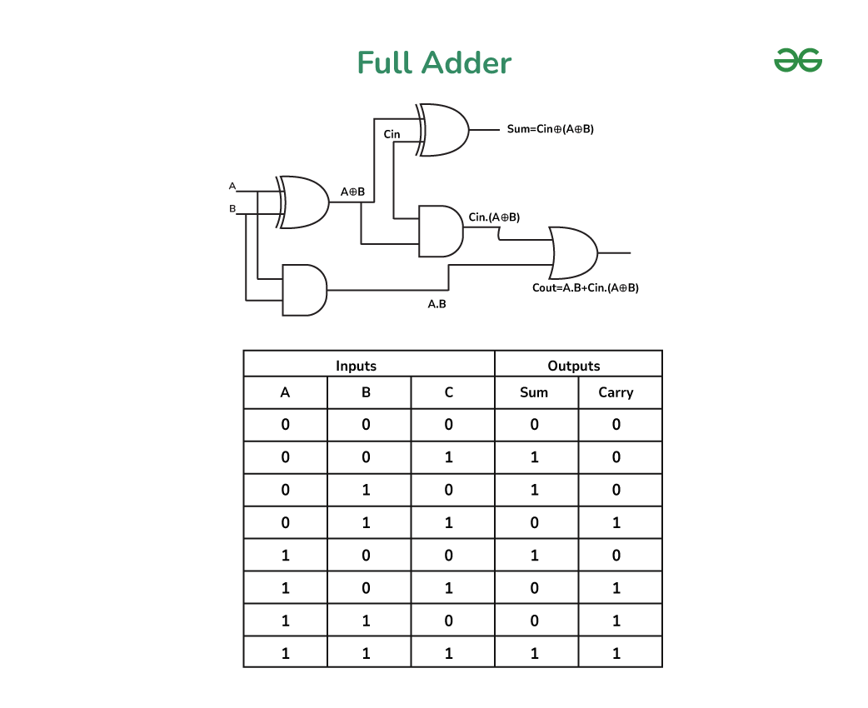Full Adder

Block Diagram for Full Adder
Below is the block diagram for full adder :

Implementation of Full Adder Using Half Adders
Below is the logic diagram to implement full adder using half adders

logic diagram of Full Adder From half Adder
Steps to Implement Full Adder from Half Adders
Steps to implement full adder from half adders in above logic diagram :
- First connect first two input with first XOR gate and first AND gate which outputs A ⊕ B and AB respectively.
- Then, connect the third input and output of first XOR gate [i.e., A ⊕ B]as input to second XOR gate which results in the sum of full adder [i.e., A ⊕ B ⊕ C].
- Then, connect the output of first XOR gate [i.e., A ⊕ B] and third input C as the input to second AND gate [i.e., (A ⊕ B)C].
- After that connect the output of first AND gate [i.e., AB] and output of second AND gate [i.e., (A ⊕ B)C] as the input to OR gate which results in the carry of full adder i.e., AB + AC + BC.
- Since, we require 1 XOR and 1 AND gate to implement half adder and in above diagram we used 2 XOR gate, 2 AND gate and 1 OR gate.
- From above point we get that to implement full adder using half adders we require 2 half adders and 1 OR gate.
Below is the block diagram to implement full adder using half adders.
block diagram to implement full adder using half adders
Steps to implement full adder from half adders in above block diagram :
- Connect first two inputs as the input of first half adder which results in two outputs sum and carry.
- Then, connect sum output of first half adder and third input as input to second half adder.
- Then, connect carry output of the first half adder and carry output of second half adder to OR gate.
- The sum output of second half adder gives us the sum of full adder.
- The output of the OR gate gives us the carry of full adder.
- Hence, to implement full adder using half adders, two half adders and one OR gate is required.
6. Explain parity generator for error detection.

Parity Bit Method
A parity bit is an extra bit that is added to the message bits or data-word bits on the sender side. Data-word bits, along with parity bits, are called a codeword. The parity bit is added to the message bits on the sender side to help in error detection at the receiver side. The binary message ensures an odd or even total of 1’s. The parity word counts 1’s in the string.
Even Parity
The total number of 1's in the given data bit should be even. So if the total number of 1's in the data bit is odd, then a single 1 will be appended to make the total number of 1's even; else 0 will be appended(if the total number of 1's is already even). Hence, if any error occurs, the parity check circuit will detect it at the receiver's end.
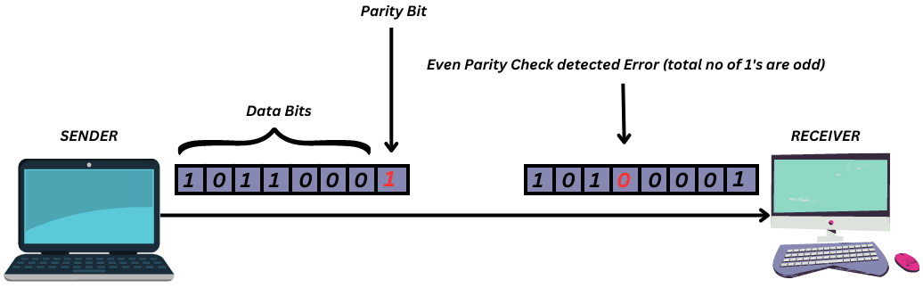
In the above image, as we can see the data bits are '1011000' and since this is even parity check that we're talking about, 1 will be appended as the parity bit (highlighted in red) to make total count of 1's even in the data sent. So here, our parity bit is 1. If the total count of 1 in the given data bits were already even, then 0 would've been appended.
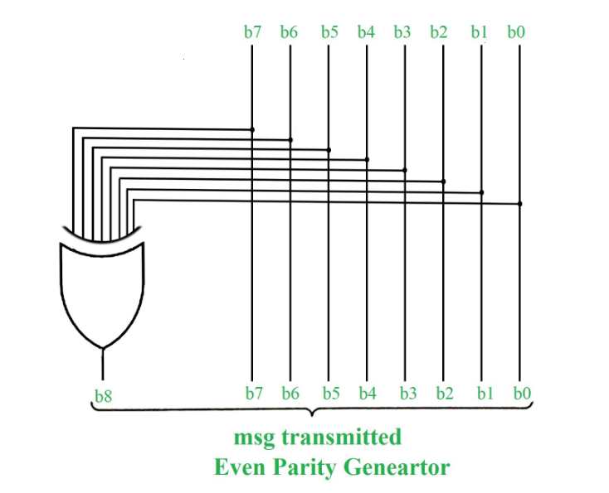
Odd Parity
In odd parity system, if the total number of 1's in the given binary string (or data bits) are even then 1 is appended to make the total count of 1's as odd else 0 is appended. The receiver knows that whether sender is an odd parity generator or even parity generator.
Suppose if sender is an odd parity generator then there must be an odd number of 1’s in received binary string. If an error occurs to a single bit that is either bit is changed to 1 to 0 or 0 to 1, then received binary bit will have an even number of 1’s which will indicate an error.
Take reference from above figure, for odd parity check, rather appending 1 as parity bit, append 0 because total number of 1's are already odd.
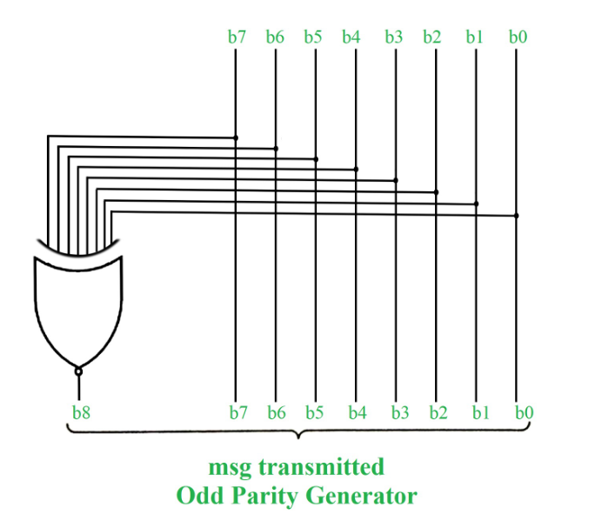
Example:
Message (XYZ) | P(Odd) | P(Even)
000 | 1 | 0
001 | 0 | 1
010 | 0 | 1
011 | 1 | 0
100 | 0 | 1
101 | 1 | 0
110 | 1 | 0
111 | 0 | 1
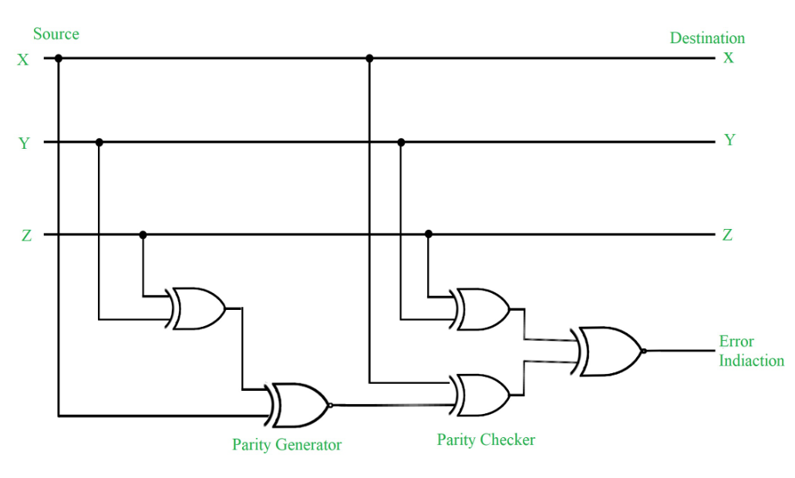Figure - Error Detection with Odd Parity Bit

7. Explain 5 bit parallel subtractor.
Parallel Subtractor
A Parallel Subtractor is a digital circuit designed to subtract two binary numbers that are more than one bit long by processing pairs of bits simultaneously (in parallel). This allows subtraction to be performed much faster compared to subtracting bit by bit in sequence.
- The parallel subtractor works by subtracting corresponding bits of the two binary numbers at the same time.
- It uses borrow signals similar to how addition circuits use carry signals to handle differences that require borrowing from the next higher bit.
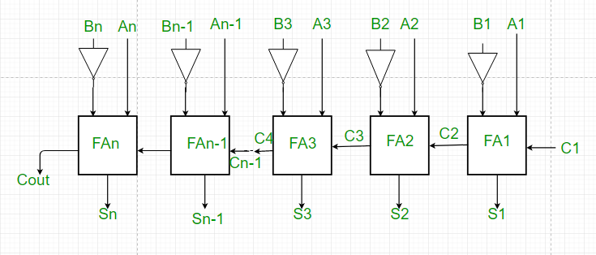
Working of Parallel Subtractor
- As shown in the figure, the parallel binary subtractor is formed by combination of all full adders with subtrahend complement input.
- This operation considers that the addition of minuend along with the 2’s complement of the subtrahend is equal to their subtraction.
- Firstly the 1’s complement of B is obtained by the NOT gate and 1 can be added through the carry to find out the 2’s complement of B. This is further added to A to carry out the arithmetic subtraction.
- The process continues till the last full adder FAn uses the carry bit Cn to add with its input An and 2’s complement of Bn to generate the last bit of the output along last carry bit Cout.

8. Show the conversion of D flio-flop to J-K flip flop.
1. Characteristic Equations
D Flip-Flop
$$Q_{n+1}=D$$
JK Flip-Flop
$$Q_{n+1}=JQ_{n}^{'}+K^{'}Q_{n}$$
To make a D FF act like a JK FF, we equate:
$$D=JQ_{n}^{'}+K^{'}Q_{n}$$

2. Truth Table Comparison
J | K | Qₙ | JK Next Qₙ₊₁ | Required D
0 | 0 | 0 | 0 | 0
0 | 0 | 1 | 1 | 1
0 | 1 | 0 | 0 | 0
0 | 1 | 1 | 0 | 0
1 | 0 | 0 | 1 | 1
1 | 0 | 1 | 1 | 1
1 | 1 | 0 | 1 | 1
1 | 1 | 1 | 0 | 0
From the column of Required D, we derive:
$$D=JQ_{n}^{'}+K^{'}Q_{n}$$

3. Logic Circuit Conversion
Connections
- Take Q output of D flip-flop and feed it back.
- Use:
  - AND gate for $J⋅Q^{'}$
  - AND gate for $K^{'}⋅Q$
  - OR gate to combine both.
- Output of OR → D input of D Flip-Flop.

Final Conversion Formula
$$\boxed{D=JQ^{'}+K^{'}Q}$$
9. Derive the characteristic equation of D flip-flop.
1. D Flip-Flop Behavior
The D (Data or Delay) flip-flop has one input D and one output Q.
Rule:
On the active clock edge, the next output simply becomes the input value.
“Whatever is at D is transferred to Q.”

2. Truth Table
D | Qₙ (Present) | Qₙ₊₁ (Next)
0 | 0 | 0
0 | 1 | 0
1 | 0 | 1
1 | 1 | 1
Observe that Qₙ₊₁ equals D regardless of the present state.

3. Characteristic Equation
From the truth table:
$$\boxed{Q_{n+1}=D}$$

Interpretation
- The next state does not depend on $Q_{n}$.
- The D flip-flop acts like a 1-bit memory register that stores the input at the clock edge.

10. Differentiate between synchronous counter and asynchronous counter.
Difference Between Synchronous and Asynchronous Counters
The following table highlights the major differences between Synchronous and Asynchronous Counters.
Key | Synchronous Counter | Asynchronous Counter
Trigger | In case of Synchronous Counters, all the constituent flip-flops are triggered with same clock simultaneously. | In case of Asynchronous Counters, there is triggering of different flip-flops with different clock.
Operation Speed | Operation speed of a synchronous counter is faster as compared to that of an asynchronous counter. | The operation speed of an asynchronous counter is comparatively slower than a synchronous counter.
Error Prone | Synchronous Counters are less error-prone; they hardly produce any decoding errors because each flip-flop is individually clocked. | Asynchronous Counters are more error-prone and produce decoding errors in the system.
Complexity | All the flip-flops in a synchronous counter coordinate with the clock, hence its design and implementation is complex as compared to that of an asynchronous counter. | In an asynchronous counter, the output of one flip-flop acts as the input of the next flip-flop, hence its design and implementation is quite simple.
Sequence | A Synchronous counter can be operated in any desired count sequence, as it could get manipulated by changing the clock sequence. | An Asynchronous counter can operate only in a fixed count sequence, i.e., UP and DOWN.
Delay | There is no propagation delay observed in case of Synchronous Counters. | In case of asynchronous counters, there is a subsequent propagation delay from one flip-flop to another.

11. Explain working of 3-bit asynchronous up counter.
3-Bit Asynchronous (Ripple) Up Counter
A 3-bit asynchronous up counter is a sequential digital circuit that counts upward in binary (0 → 7) using three flip-flops.
It is called asynchronous or ripple because all flip-flops are not driven by the same clock—the output of one flip-flop clocks the next.

Basic Idea
- Uses 3 T flip-flops (or JK with J=K=1).
- Each flip-flop represents one bit.
- Count range: 000 to 111 (0 to 7), then repeats.
- Up counter → numbers increase.

Circuit Working Concept
Assume T flip-flops with T = 1 (toggle mode).
Connections
- FF0 (LSB) → gets the external clock.
- FF1 → clock comes from Q0 (output of FF0).
- FF2 (MSB) → clock comes from Q1 (output of FF1).
So the clock “ripples” from first to last.

Counting Sequence
Let outputs be Q2 Q1 Q0 (MSB → LSB).
Clock Pulse | Q2 | Q1 | Q0 | Decimal
0 | 0 | 0 | 0 | 0
1 | 0 | 0 | 1 | 1
2 | 0 | 1 | 0 | 2
3 | 0 | 1 | 1 | 3
4 | 1 | 0 | 0 | 4
5 | 1 | 0 | 1 | 5
6 | 1 | 1 | 0 | 6
7 | 1 | 1 | 1 | 7
8 | 0 | 0 | 0 | 0 (repeat)

Step-by-Step Operation
- First Flip-Flop (Q0)
  - Toggles on every clock pulse.
  - Frequency = input clock / 2.
- Second Flip-Flop (Q1)
  - Toggles when Q0 changes from 1 → 0.
  - Frequency = clock / 4.
- Third Flip-Flop (Q2)
  - Toggles when Q1 changes from 1 → 0.
  - Frequency = clock / 8.
Each stage divides the frequency by 2, so it also acts as a frequency divider.

Why It’s Called “Ripple”
The change does not occur simultaneously.
When Q0 toggles, after a small delay Q1 toggles, then Q2—like a ripple moving through water.
This delay is called propagation delay.

Characteristics
Advantages
- Simple design.
- Fewer logic gates.
- Good for small counters.
Disadvantages
- Propagation delay increases with more bits.
- Not suitable for very high-speed operations.

In Short
A 3-bit asynchronous up counter uses three toggle flip-flops connected in series, counts from 0 to 7 in binary, and each stage triggers the next, producing a ripple effect and dividing the clock frequency by 2 at every stage.

12. Show how race around condition is eliminated by J-K flip-flop?
Race Around Condition in J-K Flip-Flop
What is Race Around?
In a level-triggered J-K flip-flop, when
$$J=1, K=1$$
the output is supposed to toggle.
If the clock pulse width is greater than the propagation delay of the flip-flop, the output may toggle many times within the same clock pulse:
$$0→1→0→1→…$$
At the end of the clock, the final state becomes unpredictable.
This repeated toggling is called the race around condition.

Elimination of Race Around Condition
The race condition is eliminated by ensuring the output can change only once per clock pulse. Two standard methods are used:

1. Master–Slave J-K Flip-Flop
Structure: Two JK flip-flops connected in series:
- Master – active when Clock = 1
- Slave – active when Clock = 0 (inverted clock)
Working
- When Clock = 1:
Master responds to J and K inputs, Slave is disabled.
- When Clock goes to 0:
Master is locked, Slave copies Master’s output once.
Because only one stage is active at a time, the output changes only once per clock cycle, removing multiple toggles.
Result: No race around.

2. Edge-Triggered J-K Flip-Flop
Instead of being level-sensitive, the flip-flop responds only at the instant of the clock edge:
- Positive edge (↑) or
- Negative edge (↓)
Since the circuit is active only for a very short instant, there is no time for repeated toggling.
Result: Single transition per clock → race condition removed.

Key Idea
Race around occurs due to long clock pulse duration in level-triggered JK flip-flops.
It is eliminated by restricting state change to a single moment using:
- Master–Slave configuration, or
- Edge-triggered design

Conclusion
A J-K flip-flop avoids race around by allowing the output to toggle only once per clock cycle, either through master–slave staging or edge triggering, thereby ensuring predictable and stable operation.

UNIT 1 – Fundamentals of Digital Systems (Important)
2 Marks
- Define a digital signal and a digital circuit.
- Convert $\left(110101)_{2}\right.$into decimal.
- Find the 2’s complement of $101011$.
- Write the truth table of a NAND gate.
- Write any two differences between TTL and CMOS.
4 Marks
- Explain number system conversions with an example.
- Explain logic families (TTL vs CMOS).
- Explain BCD code with an example.
5 Marks
- Explain binary arithmetic and 1’s & 2’s complement with examples.
- Draw and explain all logic gates with truth tables.

UNIT 2 – Boolean Algebra & Minimization (Important)
2 Marks
- State De-Morgan’s theorems.
- Define minterm and maxterm.
- What is a don’t care condition?
- Define SOP and POS.
4 Marks
- Simplify a Boolean expression using Boolean laws.
- Convert a Boolean expression into SOP / POS form.
5 Marks
- Simplify a Boolean expression using a 3-variable K-map.
- Simplify a Boolean expression using a 4-variable K-map with don’t care conditions.
- Explain the K-map minimization method with an example.
UNIT 3 – Combinational Digital Circuits (Important)
2 Marks
- Define encoder and decoder.
- What is a multiplexer?
- Define magnitude comparator.
4 Marks
- Draw and explain a half adder.
- Draw and explain a 4:1 multiplexer.
- Draw a 2-to-4 decoder with truth table.
5 Marks
- Explain a full adder with logic diagram and equations.
- Explain a binary adder/subtractor.
- Explain multiplexer and demultiplexer in detail.

UNIT 4 – Sequential Circuits (Important)
2 Marks
- Define a flip-flop.
- What is a shift register?
- Define a counter.
4 Marks
- Explain SR flip-flop with truth table.
- Explain JK flip-flop.
- Write applications of shift registers.
5 Marks
- Explain ripple counter with diagram.
- Explain shift register with applications.
- Compare synchronous and asynchronous counters.

UNIT 5 – ADC & DAC (ET)
2 Marks
- Define ADC.
- Define DAC.
4 Marks
- Explain R-2R ladder DAC with diagram.
- Explain successive approximation ADC.
5 Marks
- Explain dual slope ADC with block diagram.
- Compare ADC and DAC.

UNIT 6 – Memories & PLD (ET)
2 Marks
- Write the full forms of PLA, PAL, and FPGA.
- Define RAM and ROM.
4 Marks
- Write the difference between RAM and ROM.
- Explain types of memories.
5 Marks
- Explain programmable logic devices (PLA, PAL, CPLD, FPGA).
- Explain classification of semiconductor memories.

